File Management App L4 Automation

Table of Contents

Key Activities to implement. 2

Helper activities to implement. 3

Locator to implement. 3

PROBLEM STATEMENT

Need to automate the following activities using Selenium + Java.

BUSINESS REQUIREMENTS:

## Key Activities to implement.

1. Navigate to: [The Internet (the-internet.herokuapp.com)](https://the-internet.herokuapp.com/)/.
2. Click “example_name_link”, download it and check its working or not.
3. Check “file_to_download_link” and check its downloaded or not.
4. Check if file is downloaded in “./downloads” folder.
5. Check if delete directory is working or not.
6. Check if download folder is getting clear or not.
7. Click “example_name_link”, upload it and check its working or not.
8. Check “file_to_download_link” and check its uploaded or not.

For all the above activities to accomplish, there are template methods in Activites Class. These methods need to take use of helper methods available in SubActivites class. Those are also templated.

NOTE: "Please do not delete any file in the src folder.  But you are free to add any other file".

# Helper activities to implement.

Helper methods (in SubActivities class) to be implemented are as follows:

* + 1. Check a page has been loaded completely.
    2. Find an element using xpath.
    3. Wait for an element if it is not present.
    4. Wait for an element if it is present.
    5. Wait for an element if it is not visible.
    6. Wait for an element if it is visible.
    7. Close the ads.
    8. Close the banners.
    9. Implement do_javascript_click functionality.

# Locator to implement.

Add appropriate locators in locator class and use them in SubActivities class.

Expectations:

1. Learners should write automation script using Java and selenium to automate all the steps in the above question. In other words, automation script should perform all mentioned steps.
2. Learners should not use any tools to create the xpath. They should develop the xpath/cssselector on their own.

IMPLEMENTATION/FUNCTIONAL REQUIREMENT

* 1. **CODE QUALITY/OPTIMIZATIONS**
     1. Associates should have written clean code that is readable.
     2. Associates need to follow SOLID programming principles.

EXECUTION STEPS TO FOLLOW

1. **You are mandatory required to run test cases for applications before final submission. Without which project evaluation will not happen.**
2. **You can run the Junit test cases using Eclipse menu options.**
3. **Before final submission, you are also required to push your code to GIT. Following are the steps to follow:**

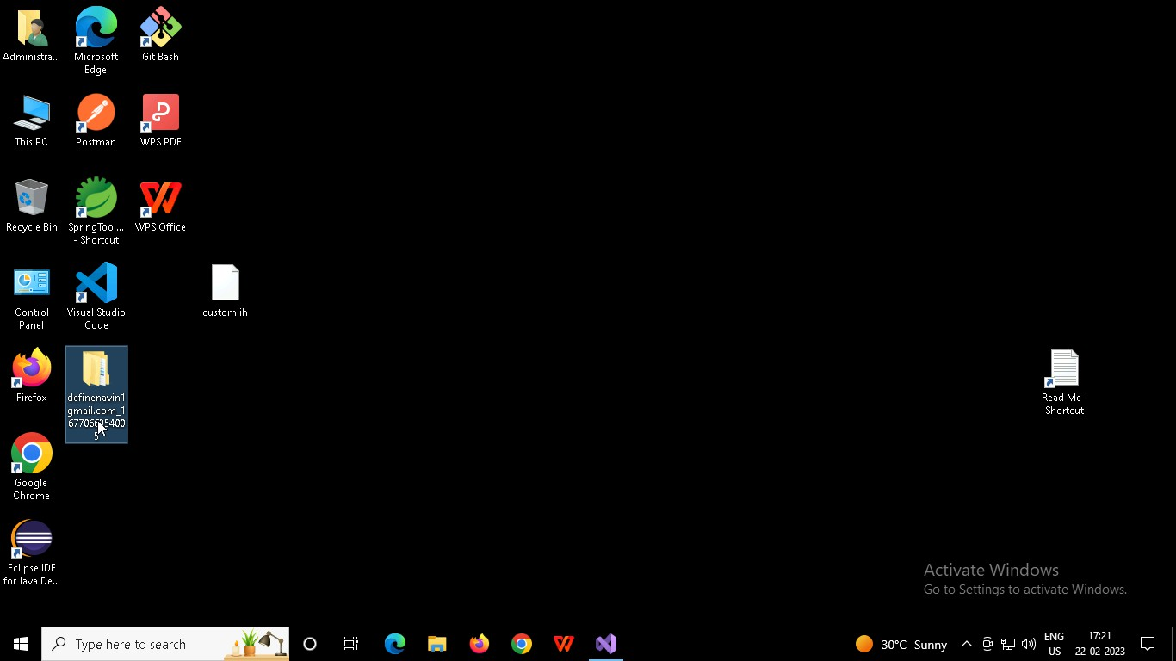

Right click in folder and open Git Bash

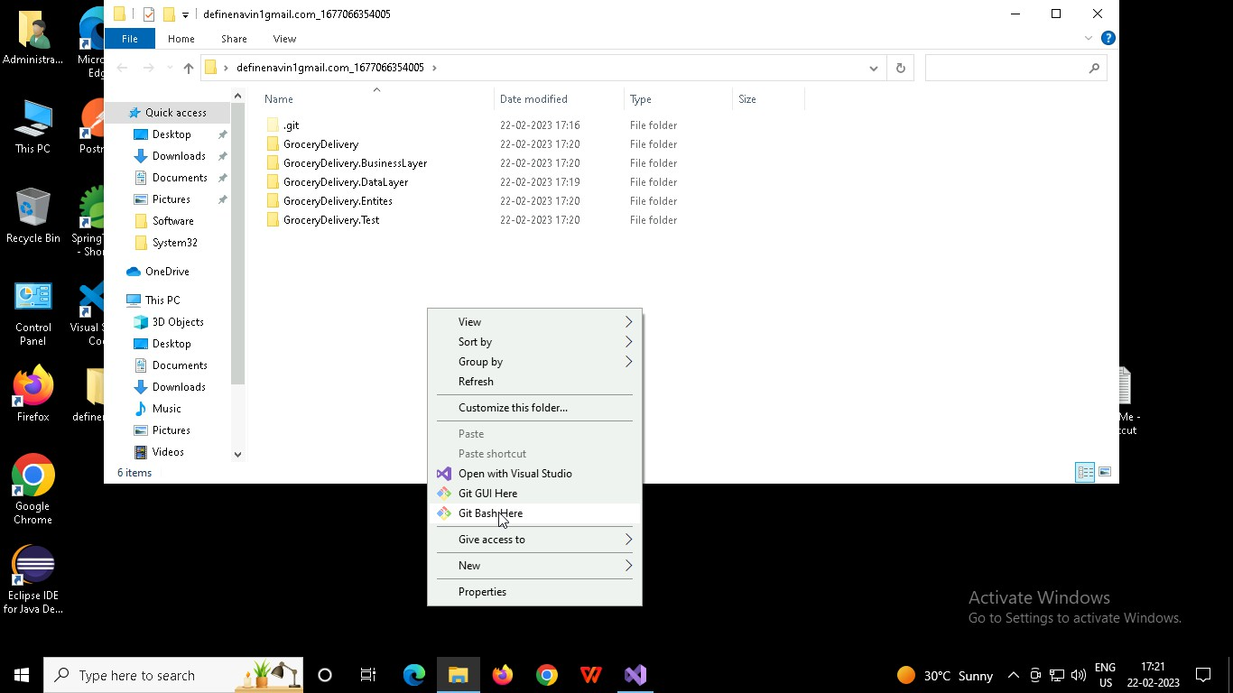

In Git bash terminal, run following commands

* 1. git status
  2. git add .
  3. git commit -m “First commit”

(You can provide any message every time you commit)

* 1. git push

